# User Interfaces

## Main Screen

When user starts the application, Main screen shows up as the first screen. Main Menu is the screen providing access to all functionalities of CrypDist.  He is also able to examine the blockchain and see the content stored in it by the provided panels. Mock-up visualization can be seen below.

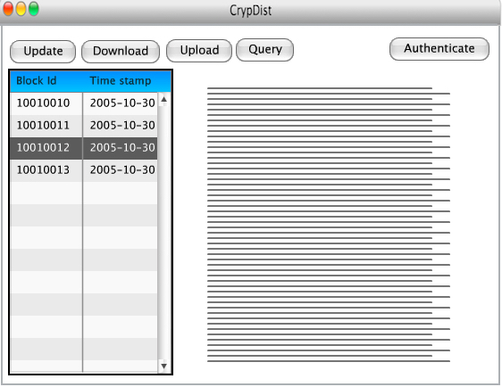

**Figure xx: Main screen**

## Update

Update screen allows user to upload a new data block instead of the chosen block in main screen. After he highlights the block to be replaced in main screen by clicking and choosing the update from the above menu, he gets redirected to the upload screen. In this screen, he locates the data to be uploaded and by choosing the upload button, he starts to upload the new data block but he always has the option to cancel the procedure in case of a mistaken choose.

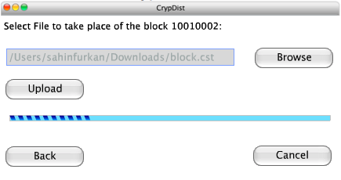

**Figure xx: Update screen**

## Download

Here we provide user the access to the raw data in servers. After he selects the block to be downloaded, he chooses the download option and the data is downloaded from the closest Akamai edge servers to his local.

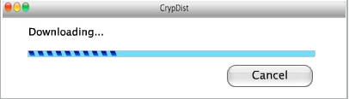

**Figure xx: Download screen**

## Upload

Upload screen is used to add a completely new data block to the system. Accordingly, blockchain is also updated and all the other pairs are notified by the change. User simply chooses the data he will upload and clicks upload, If he is authenticated to do so. According to the use cases of the system, some arguments might be also added to this screen but in a robust manner it is as shown below.

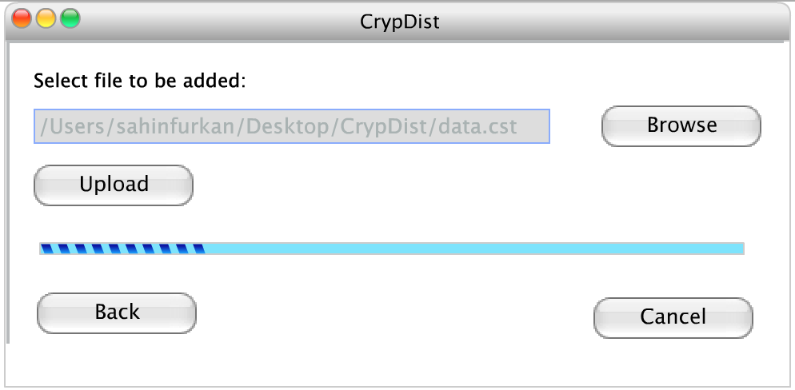

**Figure xx: Upload Screen**

## Query

CrypDist provides a query screen so that the user can run the queries on raw data. By the help of this screen he is able to understand the content of the server deeply and according to the results of the queries, he can demand to download a specific data. Query is typed in the provided screen and the results taken from the server are shown in the same screen.

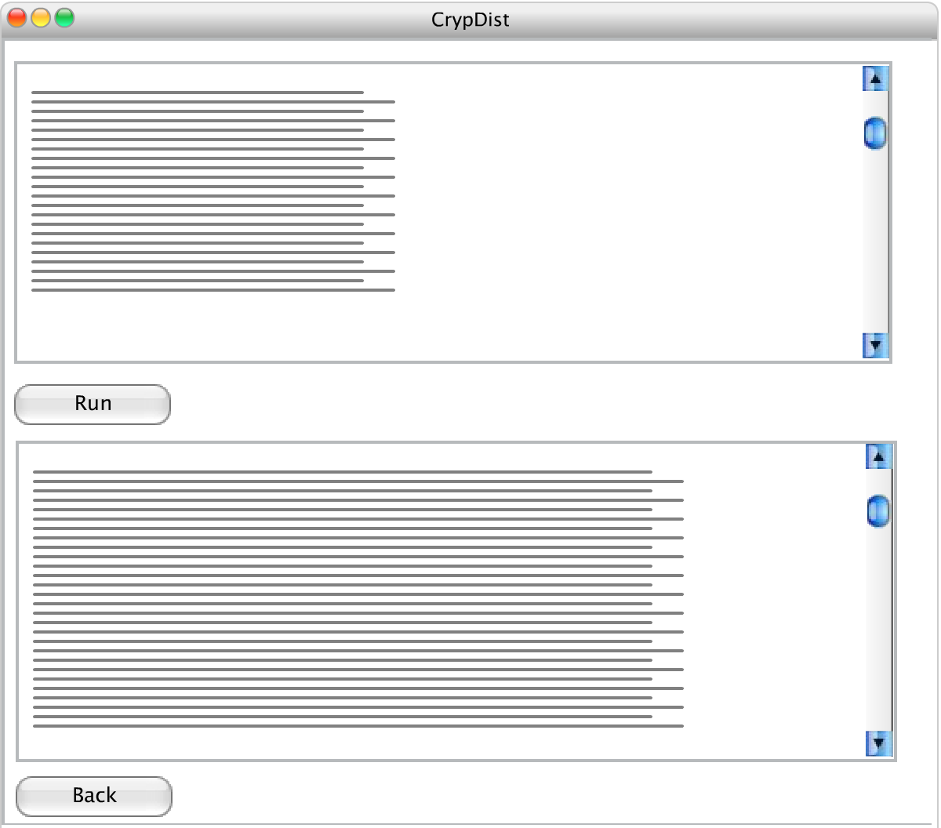

**Figure xx: Query Screen**

## Authenticate

CrypDist requires authentication for update, upload and phenotype data download purposes. Users will be able to use these functionalities if and only if they are one of our trusted users who will have an account to use these services. Authentication screen is a basic login panel which you can see below.

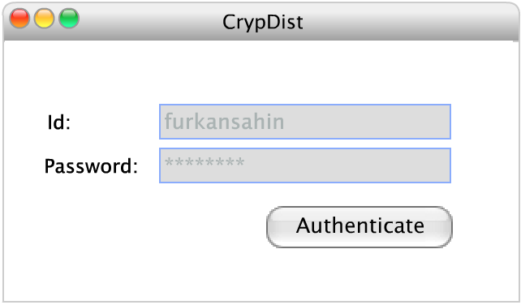

**Figure xx: Authentication screen**